Phase 1 - Setup
Step 1: Create repo- data-lakehouse-platform
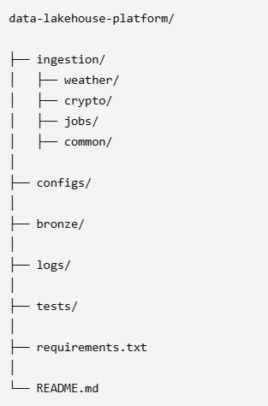
Step 2: Set up environment
Install: Python, Spark, Databricks, Docker, Airflow (optional local setup)

Phase 2 - Data ingestion
Step 1: Create reusable codes- Instead of writing one long script, create reusable components.
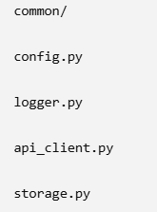

Step 2: Create configuration yaml to avoid hardcording values

Step 3: Choose APIs- Use free APIs so anyone can reproduce your project

Step 4: Create Weather API ingestion script
Use OpenWeather API
- Pull every 10-15 minutes
- Save raw JSON
Output:
/bronze/weather/yyyy-mm-dd.json

Step 5: Create Crypto ingestion
Use CoinGecko API
Track: BTC, ETH ,SOL
Store: price, volume, timestamp

Step 6: Create Job postings ingestion
Use Remotive API OR Adzuna API
Store: job title, company, location, remote flag, skills
Step 7: Docker
- Create one Docker image for the ingestion service.
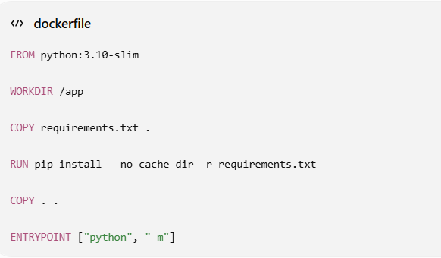

Build the image
From the project root
docker build -t lakehouse-ingestion .
Meaning
Build this Dockerfile

Name it lakehouse-ingestion

Run it : Choose the module when running the container.
Weather:
docker run -it --entrypoint bash lakehouse-ingestion
cd /app
python -m ingestion.weather.weather_ingestion
root@43cc6f4d15c3:/app# find bronze -type f
docker run lakehouse-ingestion ingestion.weather.weather_ingestion
Crypto:
cd /app
python -m ingestion.crypto.crypto_ingestion
root@43cc6f4d15c3:/app# find bronze -type f
docker run lakehouse-ingestion ingestion.crypto.crypto_ingestion
Jobs:
cd /app
python -m ingestion.jobs.jobs_ingestion
root@43cc6f4d15c3:/app# find bronze -type f

docker run lakehouse-ingestion ingestion.jobs.jobs_ingestion
This is much more flexible and aligns well with how orchestration tools invoke different tasks.

Persist bronze and logs
Without extra configuration, files written inside the container disappear when it stops.
Mount local folders into the container:
docker run -v "${PWD}/bronze:/app/bronze" -v "${PWD}/logs:/app/logs" lakehouse-ingestion ingestion.weather.weather_ingestion
Or for crypto:
docker run -v "${PWD}/bronze:/app/bronze" -v "${PWD}/logs:/app/logs" lakehouse-ingestion ingestion.crypto.crypto_ingestion
Or for jobs:
docker run -v "${PWD}/bronze:/app/bronze" -v "${PWD}/logs:/app/logs" lakehouse-ingestion ingestion.jobs.jobs_ing

Now:
- bronze/ on your computer stores ingested JSON files.
- logs/ on your computer stores ingestion.log.

Airflow integration
Later, an Airflow DAG can reuse the same image.
For example, one task could run:
python -m ingestion.weather.weather_ingestion
Another task:
python -m ingestion.crypto.crypto_ingestion
Another:
python -m ingestion.jobs.jobs_ingestion
All using the same Docker image, ensuring every pipeline runs in an identical environment.

Phase 3 -Data Lake (Bronze layer)
Store everything in raw format:
Rules:
- No transformations
- Append-only
- Partition by date
Example:
/lake/bronze/weather/date=2026-07-06/
/lake/bronze/crypto/date=2026-07-06/
/lake/bronze/jobs/date=2026-07-06/

• Azure Blob Storage (or ADLS Gen2) becomes your Bronze data lake.
• Terraform provisions the Azure resources (resource group, storage account, containers, networking if needed).
• Kafka can be introduced to simulate a streaming source (especially for weather or crypto).
• Databricks will read the Bronze data, create Silver and Gold Delta tables, and perform transformations.

Phase 4 — Processing with Spark (Day 15–25)
This is the core data engineering work
Use Apache Spark

1. Clean weather data
- remove nulls
- standardize timestamps
- convert temperature units

2. Clean crypto data
- normalize currency fields
- compute hourly averages

3. Clean job data
- extract skills (Python, SQL, AWS, etc.)
- normalize job titles

Output → Silver layer:
/silver/weather/
/silver/crypto/
/silver/jobs/

🟣 Phase 5 — Data modeling (Gold layer) (Day 26–30)
Now you simulate a real analytics team.
Create business tables

Gold tables:

1. Market dashboard table
- crypto trends
- volatility
- moving averages

2. Weather analytics table
- temperature trends
- extreme weather alerts

3. Job market intelligence table
- most demanded skills
- remote job ratio
- top hiring companies

Output:
/gold/analytics_tables/

🔴 Phase 6 — Orchestration (Airflow) (Day 30–35)
Use Apache Airflow
Create DAGs:

DAG 1
- ingest weather → transform → store

DAG 2
- ingest crypto → transform → store

DAG 3
- ingest jobs → transform → store
Schedule:
- weather: every 15 min
- crypto: every 5 min
- jobs: every 1 hour

⚙️ Phase 7 — Data quality (VERY IMPORTANT for interviews)
Add checks:
- no null timestamps
- schema validation
- duplicate detection
- freshness checks
You can use simple Python checks or dbt later.

📊 Phase 8 — Dashboard (final output)
Build a dashboard using:
- Power BI OR
- Apache Superset OR
- Metabase

Dashboard pages:
- Crypto market trends
- Weather anomalies
- Job market insights

